**East West University**

**Lab Report**

**Semester:** Fall-2024

**Course Title:** Electronic Circuits

**Course Code:** CSE251 **Sec: 03**

**Experiment No:** 05

**Experiment Name:** Adder and Amplifier Circuits Using 741 Op Amp

**Group No:** 07

**Submitted by-**

Sheikh Sarafat Hossain

2022-3-60-109

**Submitted to-**

Dr. Sarwar Jahan

Associate Professor

Department of Computer Science & Engineering

East West University

**Date of Performance: 12 December 2024**

**Date of Submission: 26 December 2024**

**Objectives:**

1. To familiarize with the 741 Op Amp Integrated Circuit (IC)
2. To design and construct an adder using 741 Op Amp.
3. To design and construct an amplifier using 741 Op Amp.

**Circuit Diagram:**

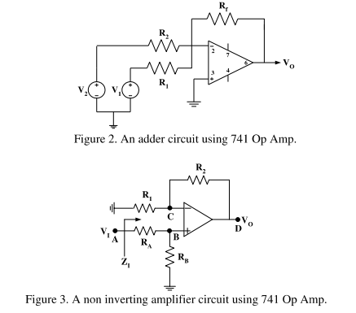

**Answer to the Pre-Lab Questions:**

An adder circuit using 741 Op Amp:

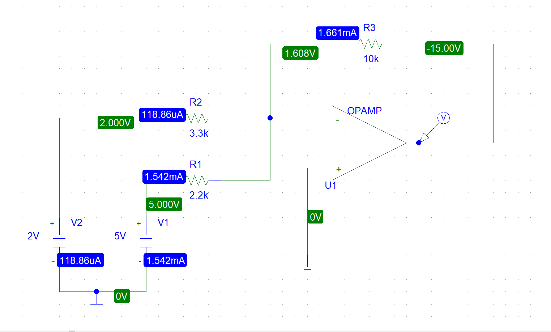

Trace of $V_{out}$:

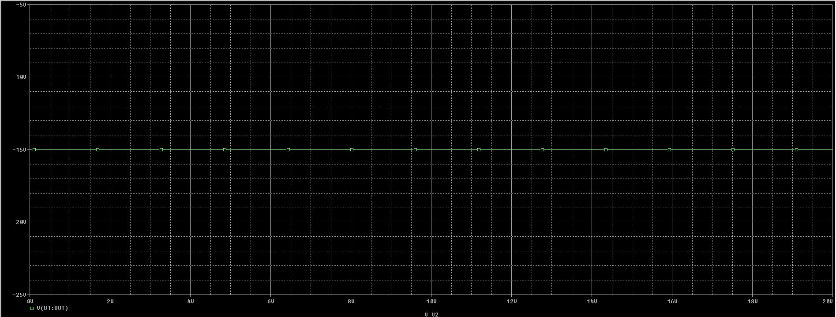

The Trace shows the relationship between output voltage and V1 which is constant.

Trace of ${I(R}_{1})$:

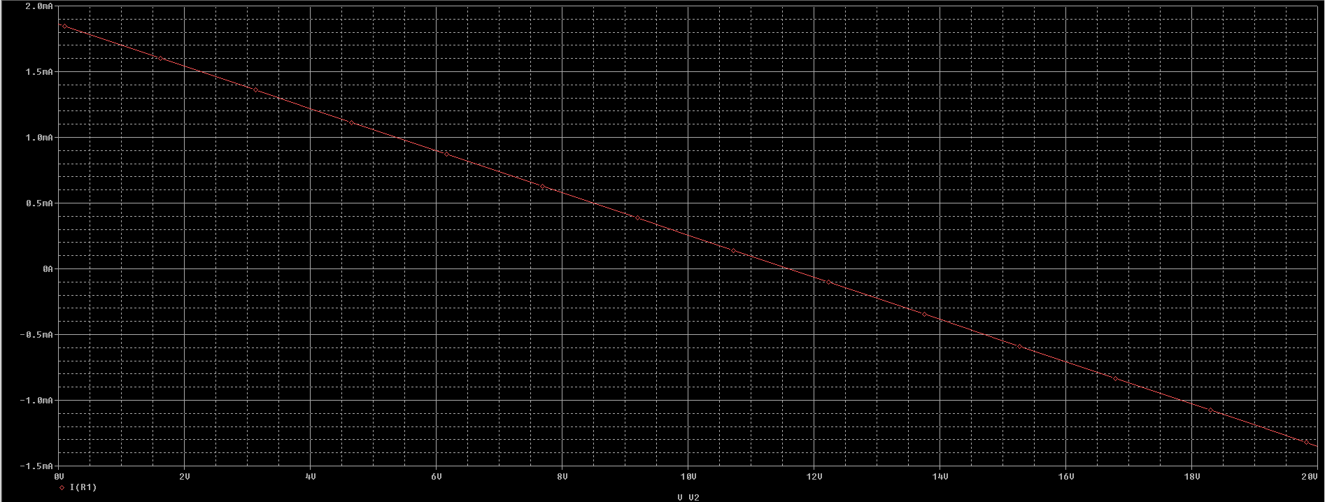

The Trace shows the relationship between current flowing through R1 and V1 which is constantly decreasing.

$V_{1}$ = 5V, $V_{2}$ = 2V, $R_{1 }$ = 2.2kΩ, $R_{2}=3.3kΩ,$ $R_{3}=10kΩ$, $V_{o }$ = -15V (from the trace)

Now, our output voltage should be

$V_{o }$ = $-\left(\frac{R_{3}}{R_{1}}V_{1}+\frac{R_{3}}{R_{2}}V_{2}\right)$

= -28.78 V

A non-inverting amplifier circuit using 741 Op Amp:

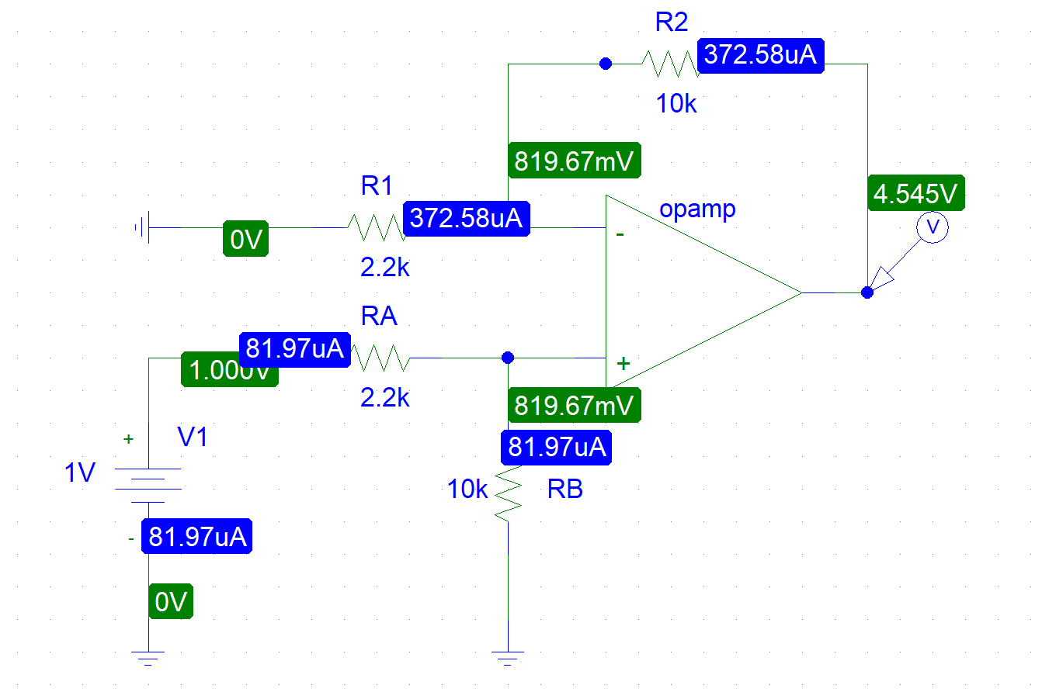

Trace of $V_{out}$:

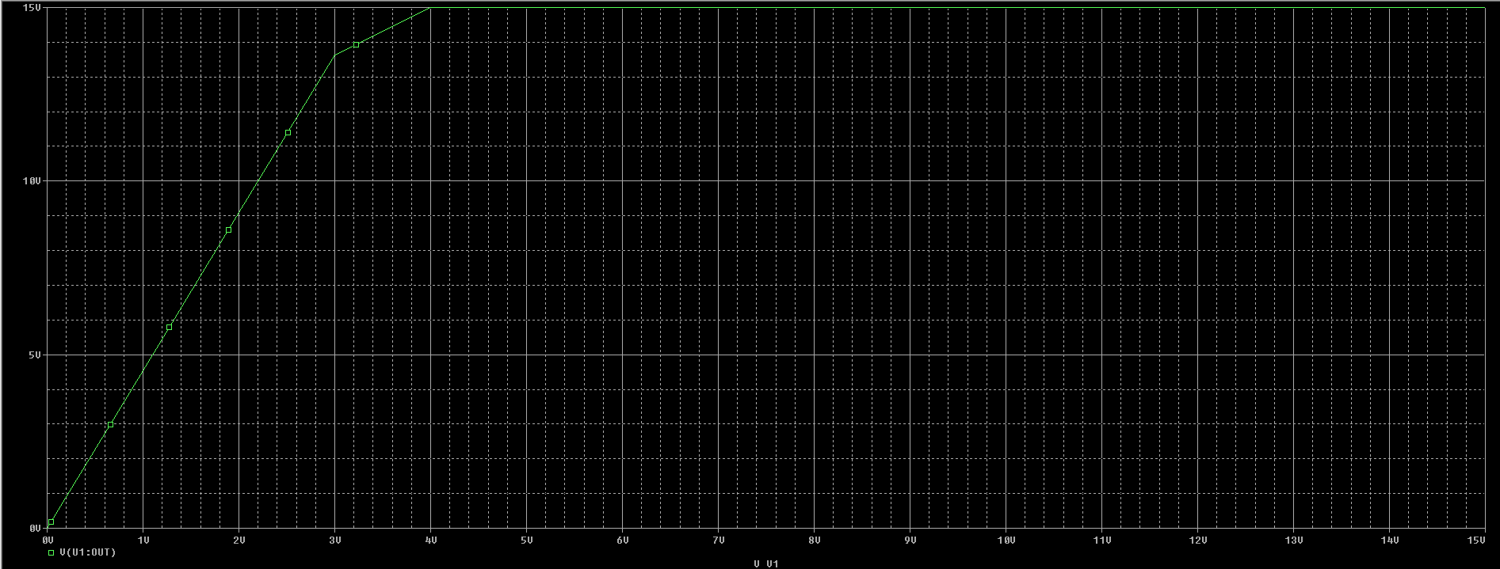

The Trace illustrates how the output voltage correlates with V1, gradually increasing until it reaches a saturation point.

Trace of ${I(R}_{2})$:

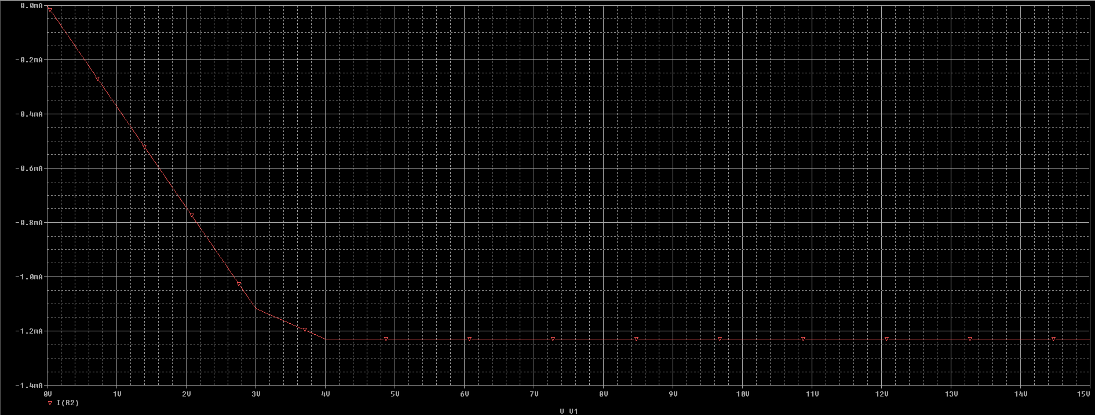

The Trace depicts the connection between the current passing through R3 and V1, progressively decreasing until it reaches a certain point and then remains constant.

Impedance, $Z_{1}=\frac{V_{1}}{I_{1}}=\frac{V_{A}}{I_{R_{A}}}=\frac{1}{0.08197}=12.2kΩ$

**Answer to the Post-Lab Questions:**

1. Here,

V1= 5v, V2= 2v, R1= 2.1 kΩ, R2= 3.2 kΩ, Rf = 9.9 kΩ

So, Output voltage V0= - {(

= - 29.758 v

But our measured output was 14.88 V. There is a huge difference between measured and calculated output voltage due to use the wrong resistor.

1. Input amplitude measured in = -4.88V

Inverted output amplitude measured in = -9.57 V

Since input amplitude-inverted output amplitude, this verified our design of the summer circuit using op-amp.



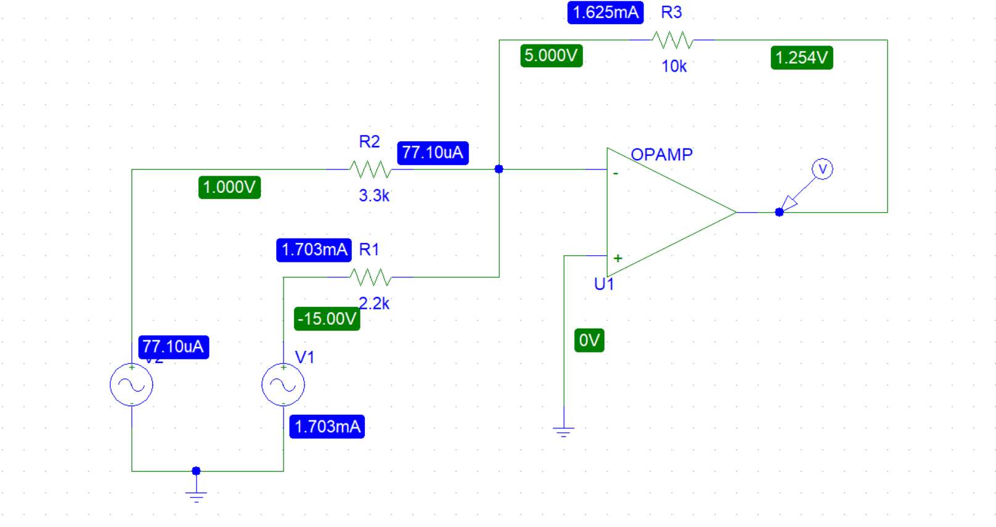

1. Comparing the measured voltages at node A, B, C and D in step 8 with our prelab values:

|  |  |  |  |
| --- | --- | --- | --- |
| Nodes | Measured Values | Pre-Lab Values | Difference |
| A | 0.0067 V | 1 V | 0.9933 V |
| B | 0.0047 V | 0.819 V | 0.8143 V |
| C | 0.005 V | 0.819 V | 0.814 V |
| D | 0.01 V | 4.545 V | 4.535 V |

1. Using a virtual ground simplifies circuit analysis by treating specific points as zero potential. In an Adder Circuit experiment, node voltages at B=0.0047 V and C=0.005 V confirm the validity of the virtual ground approximation, with values close to zero indicating accurate circuit behavior. This technique streamlines calculations, enhancing accuracy and ease of analysis in circuit design. The virtual ground concept proves invaluable for simplifying complex circuits while maintaining precision, highlighting its significance in practical applications for engineers and researchers alike.
2. Measured voltages of node A and D from step 8 are,

VA=0.0067 V

VD=0.01 V

So, Gain = $\frac{V_{D}}{V_{A}}$ =1.49

Our previously calculated gain was 4.545. Measured gain has discrepancy due to calculation error in the ratio of R1 and R2

1. From post-lab we got,

$R_{1}$ = 2.2kΩ, $R_{2}$ = 3.3kΩ, $R_{A}=3.2kΩ,$ $R_{B}$ = 4.6kΩ

$V_{R1}$ = 0.0045V, $V_{R2}$ = 0.0043V, $V_{RA}$ = 0.0049V, $V_{RB}$ = 0.005V

By using this value we find,

$$I_{1}=\frac{v_{R_{1}}}{R_{1}}=2.045{x10}^{-3}mA$$

$$I_{2}=\frac{v_{R2}}{R_{2}}=1.303x{10}^{-6}mA$$

$I_{A}=\frac{v_{R_{A}}}{R_{A}}= 1.53x{10}^{-6}mA$

$I_{B}=\frac{v_{R_{B}}}{R_{B}}=1.087x{10}^{-6}mA$

But we can find the measurement values of pre-lab by using pspice simulation is,

$$I_{1}=0.3725mA$$

$$I_{2}=0.3725mA$$

$$I_{A}=0.0819m$$

$$I_{B}=0.8196mA$$

The calculated values from the experiment have huge difference from the calculated pre-lab values. Because, we have big difference with resistance value in post lab. While making circuit board have some lack of concern the experimental data.

1. VA= 0.0067 V

$V_{R_{1}}$ = 0.0045 V

R1 = 2.2 kΩ

= = = 2.045 × 10-3 mA

So,

And from Pre-lab Z1= 12.2 kΩ

There is a discrepancy of 8.474 kΩ between measured and pre-lab impedance due to calculation error of the ratio of R1 and R2 .

**Discussion:**

